Architecture Diagram & Justification
The MediCore cloud infrastructure was implemented using a three-tier architecture. It includes a public subnet hosting the MediCore-Bastion-VM-01, which acts as the single-entry point, a private subnet hosting MediCore-Web-VM-01, providing application services without being exposed to the internet, and a restricted subnet hosting the medicore-db , Amazon RDS PostgreSQL database, which allows database traffic only from the web tier. Other supporting services include Amazon S3 for secure file storage, CloudWatch for monitoring and alerting, IAM roles for access control, and automated database backups with Point-in-Time Restore capabilities.
Several design decisions were made to achieve better security and resilience of the infrastructure. First, a three-tier architecture was chosen because it enables network segmentation and minimizes the attack surface. Multi-tier architectures are widely recognised as a security best practice because they separate workloads and restrict direct access to sensitive systems. (AWS, 2024) Second, the principle of least privilege was applied by using Security Groups that restrict communication between infrastructure tiers. Security Groups ensure only authorised traffic is permitted between components, reducing the risk of unauthorised access and supporting the principle of least privilege (NCSC, 2023). Third, data encryption at rest and in transit was achieved using AWS KMS, SSE-S3 and HTTPS/TLS respectively to protect sensitive NHS patient data. CloudWatch monitoring and alerting were implemented to enable proactive detection of security and performance issues.
The architecture provides protection of patient data at multiple boundaries. Internet users have access only to the web tier, whereas administrative access is restricted through the Bastion Host. The database is located within the restricted subnet and therefore cannot be reached from external networks. Security Groups limit the communication to only authorised traffic, thus reducing risks of unauthorised access. Security Groups and encryption support confidentiality and integrity, while automated backups, recovery capabilities and monitoring support availability and resilience.
There were some limitations of the free-tier and student account usage which affected the deployment. The Auto Scaling and Load Balancer solution was successfully demonstrated within two Availability Zones instead of three. Within the production deployment, this solution would be scaled out to cover three Availability Zones to achieve higher fault tolerance. More powerful instances and further redundancy would be implemented in a production deployment to handle larger loads.
In a production deployment, the solution would be extended across three Availability Zones to provide greater resilience and fault tolerance in line with AWS high-availability recommendations (AWS, 2024).

An agile approach was used in the deployment of the infrastructure. The components of the infrastructure were implemented incrementally, tested separately and fine-tuned based on results prior to moving to the next stage. This approach suited MediCore since it enabled low implementation risks, continuous security validation and improvements.

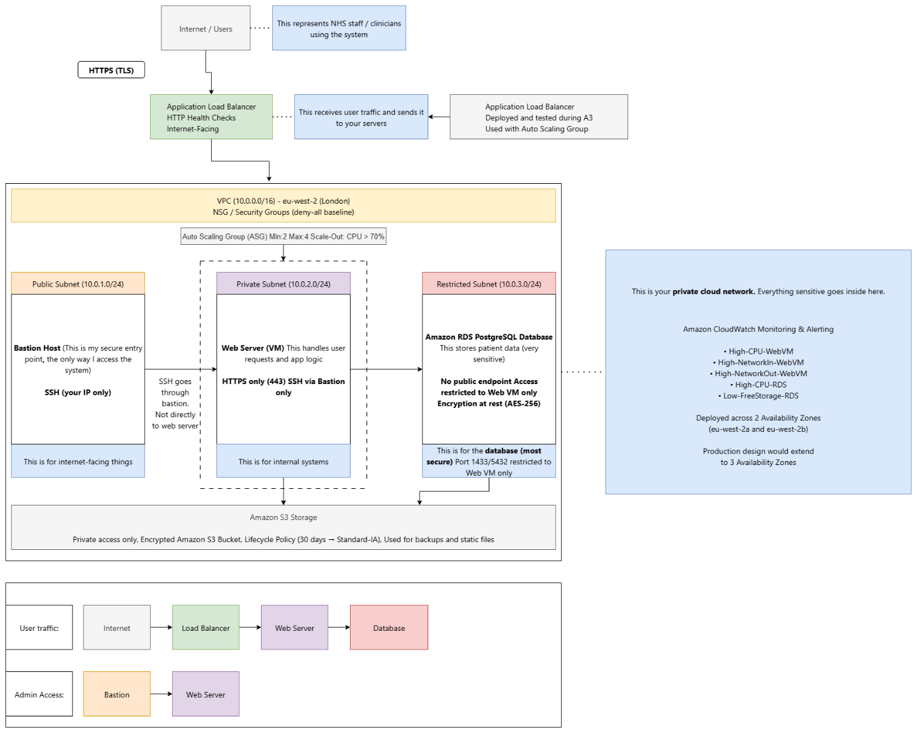

References
- Amazon Web Services (2024) AWS Well-Architected Framework. Available at: https://docs.aws.amazon.com/wellarchitected/latest/framework/welcome.html (Accessed: 24/08/2026).
- National Cyber Security Centre (2023) Cyber security design principles. Available at: https://www.ncsc.gov.uk/collection/cyber-security-design-principles (Accessed: 24/08/2026).

